## Google translation version

## The book was published by the Moscow State University Publishing House, in the series “Works of Outstanding Scientists of Moscow State University”

***V.M. Lipunov, V.G. Kornilov, E.S. Gorbovskoy, N.V. Tyurina, A. Kuznetsov***

# ASTRONOMICAL ROBOTIC NETWORKS

**And**

**OPERATIONAL MULTICHANNEL ASTROPHYSICS**

**Using the example of the MASTER global network.**

## 700 pages

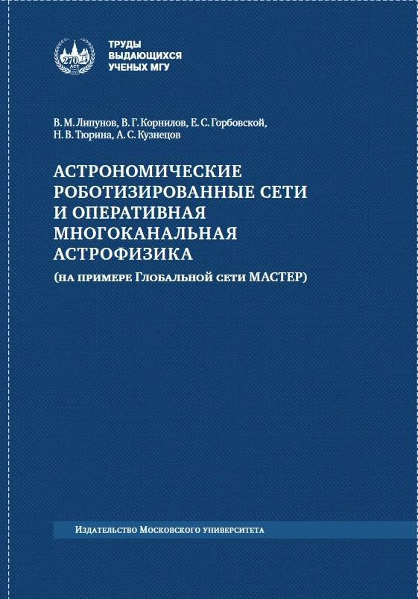

*The first astronomical networks of robotic telescopes appeared in the 21st century, and in your hands is the first monograph in world literature dedicated to describing the principles of the creation and operation of fully robotic telescopes united in a global network. The authors of the monograph are themselves active developers and users of the MSU MASTER network. However, they did not limit themselves to simply* *describing the work and presented the most striking results in various fields of astrophysics - from gamma-ray bursts and the search for sources of gravitational wave bursts to the search for potentially dangerous asteroids and comets. That is why this monograph will be of interest not only to experimentalists working with the acquisition, processing and publication in real time of large databases, but to theoretical physicists and astrophysicists working in the most exciting areas, such as gamma-ray astronomy, gravitational wave astronomy, high particle acceleration physics and ultra-high energy, neutrino extragalactic astronomy, astrophysics of massive and supermassive black holes, researchers of the properties of superdense matter represented in our Universe by white dwarfs and neutron stars, and, finally, ultra-fast astronomical phenomena associated with magnetars: Fast Radio Bursts, short gamma repeaters and anomalous X-ray pulsars.*

**Content**

Preface.

**Chapter I. History of the issue.** 1.1.Where does a robot start? 1.2.Antigravity!?

1.3.Microlensing

* 1. Gamma-ray bursts
  2. The first Russian robot telescope.

### Chapter II. Principles of construction of the MASTER Global Network

* 1. Characteristics of the location of network points
  2. Equipment complex MASTER II
  3. Information and hardware structure of the complex
  4. Information and software structure of the complex

2.5. Planning and conducting observations

2.6 Automatic image processing, databases

2.7. Control of MASTER II telescopes and initial analysis of observations

2.8 Capabilities of MASTER telescopes

2.9. Space segment of MASTER at the Lomonosov observatory.

### Chapter III. Principles of Data Stream Processing

* 1. Relationship between observation and image processing
  2. Shooting calibrations and processing calibration frames.
  3. Saving source images to a database. Frame processing queue.
  4. Building a database of all the stars from each frame in the image.
  5. Search for OTs of various natures based on original data. (Asynchronously)
  6. Quick OT and telegrams for alert shooting.
  7. Search for moving objects.
  8. Generating summary frames.
  9. Construction of differences. Methods for calculating difference frames.
  10. Processing wide-field cameras.

### Chapter IV. Creation of a robotic network MASTER

* 1. Observation processing, Big Data and distributed databases
  2. Need for a central base
  3. Creation of a Dynamically Integrated Database for the robotic network MASTER
  4. Central network scheduler MASTER
  5. Basic operating principles
  6. Calculating the priority of a specific site
  7. Restricted areas
  8. Operating modes
  9. Center for operational control of telescopes of the Global Network MASTER

### Chapter V. Interactive tools for astronomical data analysis

* 1. Rapidly Variable Objects: Analysis
  2. Tools for analyzing astronomical observations
  3. Generation and automatic publication of telegrams

### Chapter VI. Gamma-ray bursts: early observations, interpretation and the “central engine” model

* 1. Discovery of the polarization of the intrinsic optical radiation of gamma-ray bursts.
  2. Observations of gamma-ray bursts 2002-2011
  3. Observations of 130 gamma-ray bursts 2011-2017
  4. Observations of 52 gamma-ray bursts 2017-2019
  5. Universal optical light curve: SOS emission
  6. Synchronous multichannel observations of the self-emission of the gamma-ray burst GRB 161017A by the MASTER network and the Lomonosov space observatory
  7. Successful localization of a gamma-ray burst with poorly defined coordinates GRB 140801A
  8. The central engine of gamma-ray bursts in the Spinar paradigm.

### Chapter VII. Optical localization of gravitational wave sources.

* 1. Search for optical transients in the error field of the first gravitational wave burst GW150914.
  2. First successful optical localization of a gravitational wave source.
  3. Search for optical transients in error fields when LVC gravitational wave detectors are turned on: O1, 02, 03. 10
  4. Dominance of black holes over neutron stars in gravitational wave detectors.

**Chapter VIII. Search for sources of high energy neutrinos.**

* 1. Search for sources of high and ultra-high energy neutrinos.
  2. Early optical observations of the squared errors of high-energy neutrinos IceCube-170922A
  3. Mass operational observations of neutrino events MASTER..

### Chapter IX. Search and monitoring of sources of fast radio bursts

* 1. The phenomenon of Fast Radio Flashes in the Universe.
  2. First attempts at optical localization of fast radio bursts.
  3. Coincidence method.
  4. Optical monitoring of two nearby sources of fast radio bursts
  5. Origin of the Magnetars

### Chapter X. Discoveries and observations of unique objects and phenomena.

10.1. Monitoring the historic 2015 flare of microquasar V404 Cyg 2

10.2 Rare Red Nova MASTER OT J004207.99+405501.1/M31LRN 2015 - Merger of ordinary stars in the Andromeda Galaxy?. 5

* 1. Antiransient MASTER OT J095310.04+335352.8 - the longest-period eclipsing object with unexplained properties 6
  2. Discovery and tracking of potentially dangerous asteroids and comets 6
  3. First detection of an orphan surge at growth stage 6

**Chapter XI. Catalog of transients of the synoptic survey of the MASTER Global Network.**

### 11.1 The description of catalogue. 11.2. The Catalogue of 3080 discovered optical transients